Logo | Clinic name  Address · Phone · Licence no.

Dermatology and aesthetics treatment record
Page one before the first session; page two is filled in at every session.
Patient name: | File no.: | Date of birth:
Phone: | Date: | Doctor:

Skin type and concerns
Skin type (Fitzpatrick) ☐ I ☐ II ☐ III ☐ IV ☐ V ☐ VI
☐ Acne | ☐ Pigmentation | ☐ Melasma | ☐ Scars
☐ Wrinkles | ☐ Volume loss | ☐ Unwanted hair | ☐ Redness or rosacea
☐ Sensitive skin | ☐ Laxity | ☐ Enlarged pores | ☐ Other:
Planned treatment: | Expected sessions:

Contraindications
Pregnancy or breastfeeding ☐ Yes ☐ No | Isotretinoin (current or recent) ☐ Yes ☐ No
Photosensitising medication ☐ Yes ☐ No | Recent sun exposure or tan ☐ Yes ☐ No
History of keloid or raised scars ☐ Yes ☐ No | Active infection at the area (including cold sores) ☐ Yes ☐ No

If yes: details: | Reviewed by and date:

Area map
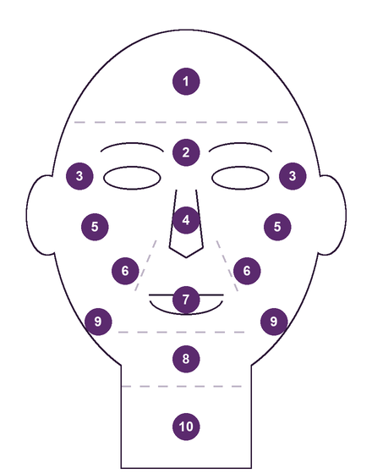  Face | 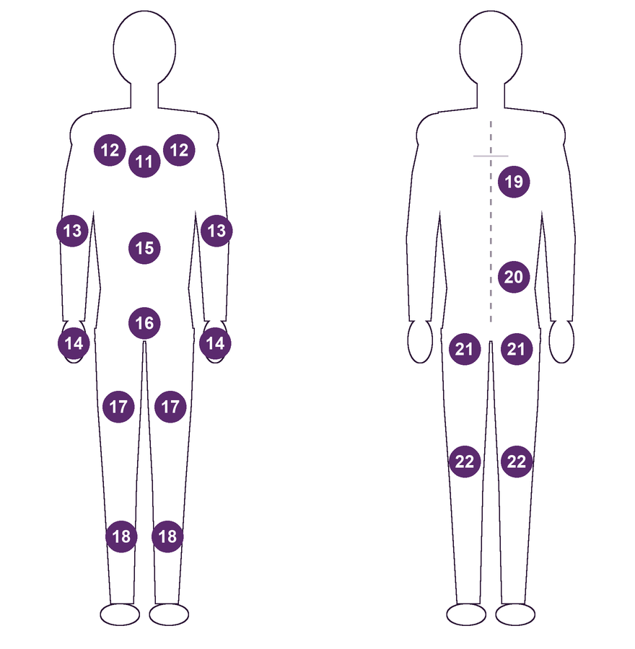  Front Back
1. Forehead | 2. Between the brows | 3. Around the eyes | 4. Nose
5. Cheeks | 6. Nasolabial folds | 7. Lips and around the mouth | 8. Chin
9. Jawline | 10. Neck | 11. Chest | 12. Underarms
13. Arms | 14. Hands | 15. Abdomen | 16. Bikini area
17. Thighs | 18. Lower legs | 19. Upper back | 20. Lower back
21. Buttocks | 22. Back of the legs
Write the zone number in the session table. Shade or mark the area treated.

Protocol per session
Date | Session no. | Device or product | Settings or units per zone | Lot no. | Operator | Reaction | Next session

Photo log
Date | View (front, right, left) | Consent to photograph | Taken by | Stored in

Home care given
☐ Sunscreen | ☐ Gentle cleanser | ☐ Moisturiser | ☐ Avoid direct sun
☐ Avoid heat and sauna | ☐ Written aftercare sheet | ☐ Prescribed product | ☐ Other:
Products and how to use them:

Doctor’s name and signature | Patient signature | Date
In Medicolize this document lives on the patient file: medicolize.com

